To install NLTK (Natural Language Toolkit), you can use pip, which is the Python package installer. Here are the steps to install NLTK:

1. Open a terminal or command prompt window.
2. Run the following command to install NLTK using pip:

Copy code

1. 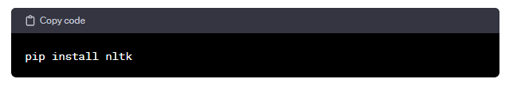Once the installation is complete, you can verify if NLTK is installed correctly by opening a Python shell and importing NLTK:

pythonCopy code

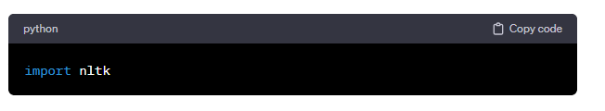If there are no errors, NLTK has been installed successfully.

After installing NLTK, you might also need to download additional resources such as tokenizers, corpora, and models. You can do this using the NLTK downloader. To download all necessary resources, you can run the following Python code:

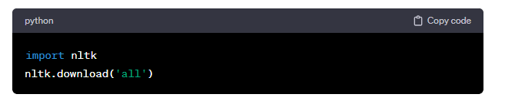Or, if you only need specific resources, you can specify them by name, like this:

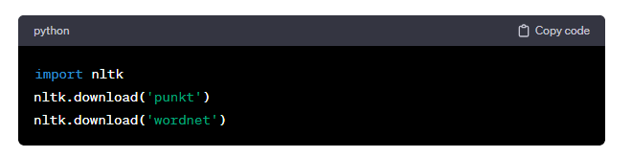This will download the Punkt tokenizer and the WordNet corpus, which are commonly used resources for tokenization and lemmatization in NLTK.

Once downloaded, NLTK is ready to be used in your Python projects for natural language processing tasks.